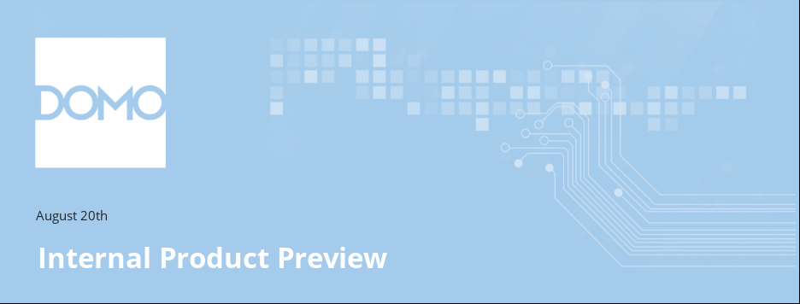
Preview features coming to domo.domo 🆕:
Fellow Domosapiens, the Product Development Team has new features for you to test drive. We’re excited to release these features early to Domosapiens so that you can try them before they go out to customers.
The following information is for internal use only.
_____________________________________________________________________________
This Product Preview includes the following updates:
In addition to the details below, you can find demo videos and more information about these new features in the Product Release Training App on domo.domo.
CLOUD INTEGRATION
- Portable JSON connector definitions let you export and import JSON No Code connector configurations across instances
- Natively create OAuth-only, read-only integrations for engines that support OAuth — Databricks, Snowflake, and BigQuery
ORGANIZE
- Discovery AI Tools let Domo AI agents manage Workspaces and Alerts conversationally, with permissions respected
TRANSFORMATION
- Expose a Workflow to AI agents through a dedicated, governed MCP trigger
VISUALIZE + INTERACT
- Pvariable support applies variables on load via a page URL parameter in Dashboards, App Studio, and Embed
- New KPI templates in App Components let builders create custom-looking KPI components with no code
- A new Numeric widget in App Components aggregates and formats a column with a simple dropdown selection
- Group By and aggregations are now available in every App Component through the Filter pane
- Apply conditional formatting to App Component widgets
- New Chart Improvements in App Studio and Analyzer
CONNECTION
PORTABLE JSON CONNECTOR DEFINITIONS
Customers who run more than one Domo instance often configure the same JSON No Code connectors to reach the same endpoints and systems. Because DataSets can’t be shared across instances, they have to recreate each configuration by hand or copy it over manually.
You can now export a JSON No Code connector definition from one instance and import it into another, reusing an existing configuration instead of rebuilding it. This saves setup time and lets less technical users stand up a JSON No Code DataSet quickly.

CLOUD INTEGRATION
OAUTH-ONLY READ-ONLY INTEGRATIONS
Enterprises that standardize OAuth previously had no native way to create a read-only, OAuth-only integration for their cloud data engines.
Domo now lets you natively create an OAuth-only integration that is read-only for every engine that supports OAuth — Databricks, Snowflake, and BigQuery — so you can connect with user-to-machine OAuth authentication without configuring other credential types.
ORGANIZE
DISCOVERY AI TOOLS
Managing Workspaces and Alerts has meant working through the UI for each change, one entity at a time.
Discovery AI Tools expose MCP-compatible tools that let Domo AI agents operate on Workspaces and Alerts on your behalf, so you can manage them conversationally through Domo AI. Capabilities include:
- Full create, read, update, and delete for Workspaces and Alerts
- Management of related concepts such as items, folders, subscribers, and sharing or permissions
- Permission-aware behavior — every tool respects the calling user’s access to the underlying resources
AUTOMATION
MCP TRIGGER IN WORKFLOWS
As AI agents become a primary way people interact with business systems, Workflows need a native entry point built for AI-initiated automation. Today AI can start a Workflow only through triggers designed for other use cases, so there is no purpose-built, sanctioned path.
The new MCP trigger gives AI a supported, governed, and purpose-built way to start a Workflow directly. It establishes a clear contract for AI-initiated automation instead of repurposing triggers meant for something else.
Add the MCP trigger to a Workflow’s canvas to expose that Workflow as a sanctioned entry point for AI agents.
VISUALIZE + INTERACT
PVARIABLE SUPPORT FOR DASHBOARDS, APP STUDIO & EMBED
Domo has added pvariable support across Dashboards, App Studio, and Embed. You can pass a page URL parameter to apply variables when the page loads, so a link can open with the right variable values already in place.
NEW KPI TEMPLATES IN APP COMPONENTS
Choose a Template now includes a KPI category with three pre-built layouts. One is a square grid of equal-weight metrics; the other two pair a single hero metric with a supporting grid, positioned on either side. Each arrives with the structure and spacing already set, so builders can drop in widgets, point them at a DataSet, and end up with a component that looks custom-built — without writing any code.

App Components now has a Numeric widget for putting a single aggregated value on screen.
Pick a column from your DataSet, choose an aggregation from a dropdown, and you're done — Sum, Average, Count, Min, Max, and Distinct Count are all supported. The full set of numeric formatting controls comes with it, including number format, decimals, prefix and suffix, and abbreviations, so you can go from raw column to a display-ready value in one place.
GROUP BY & AGGREGATIONS IN APP COMPONENTS
Every App Component now supports Group By and aggregation, surfaced through the Filter pane.
- A new “Group by” category in the Filter pane provides a multi-select of the columns powering the component
- On non-numeric widgets, once a Group By exists, any additional text column you add is automatically appended to the Group By — this applies only after the first Group By is set
CONDITIONAL FORMATTING FOR APP COMPONENTS
You can now apply conditional formatting to App Component widgets, styling values based on rules, so the numbers, icons, and text that matter most stand out.

NEW CHART IMPROVEMENTS IN APP STUDIO and ANALYZER
Three new chart types and rounded bars — so your app can show more kinds of data, and look modern doing it.
The Multi progress bar gives every category its own row, showing actual, max, and target in a single line. The Symbol matrix plots two dimensions in a grid, sizing and coloring each symbol by value. The Ribbon Chart connects stacked segments across categories, so shifts in share and rank read as movement. And bars now support rounded corners, giving charts across your app the same soft edges as the rest of your design.

__________________________________________________________________________
We’re excited about this latest set of enhancements. Take them for a spin and let us know what you think in the DPT – Development | EXTERNAL Product Feedback | Microsoft Teams.
Thank you!
Domo Product Development
Domo inc 802 E 1050 S, American Fork, UT 84003
CONFIDENTIAL

